**File: Dimitur_Nesterov_7_0d5526.rb**

Task:

#Develop a program named FirstName_LastName_ClassNumber_0d5526.rb

#

#1. you are given an argument for a folder with files;

#1.1 if there are other arguments they should be discarded

#2. file names in this folder are in the form First_Last_digits.rb;

#3. find all the students that have 10 letters in their first name;

#4. Sort the result by Last Name DESC.

#5. Produce a result in CSV format named result.csv:

#

# FirstName1,LastName1

# FirstName2,LastName2

# ...

# FirstNameN,LastNameN

Code:

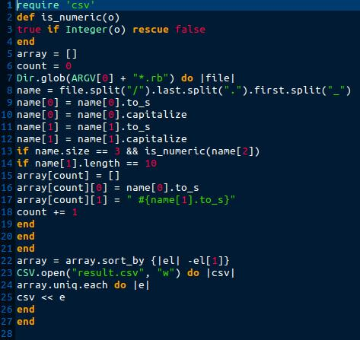

Errors:

* In line 22: undefined method `-@' for " Sec":String (NoMethodError) ; {|el| -el[1]} must be {|el| el[1]}
* In line 14: name[1].lenght must be name[0].lenght
* In line 22: {|el| el[1]} must be {|el| el[1]}.reverse

New code: 